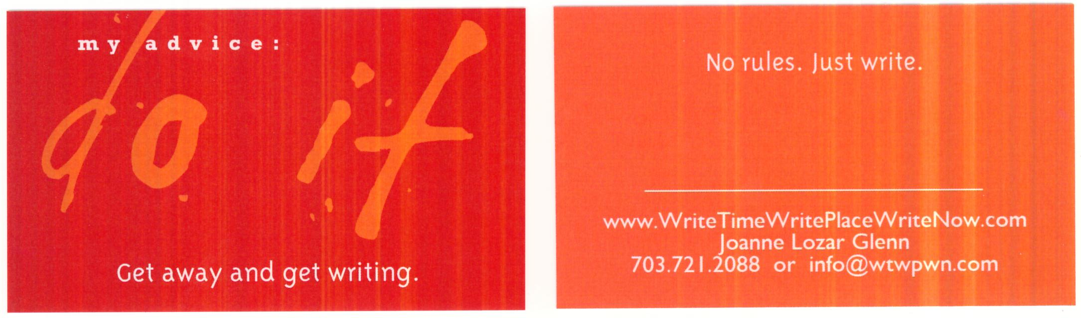

FAQs: Get Away & Get Writing
What Is “Get Away & Get Writing”?
Get Away & Get Writing is a “Write Time, Write Place, Write Now” weekend writing retreat designed to reacquaint you with the writer within and re-energize your writing practice. Held in Rehoboth, Delaware—just two blocks from the beach—this retreat lets you remember and luxuriate in the deliciousness of what it means to create:
- the initial strangeness of facing the blank page
- the temerity of making those first marks on paper
- the rush of words as you “click” into what’s waiting to be expressed
- the camaraderie of immersing yourself once again in the community of writers
- the satisfaction that comes with knowing you’ve got the seeds of a story and the skills to polish it into something wonderful

What’s the Program?
Friday evening begins with a welcoming reception and workshop preview. Then we’ll share dinner onsite. The evening is free to socialize, walk around town or on the beach, or just enjoy your own solitary company.
On Saturday after breakfast, we gather for the workshop. Expect to read, to write, to share ideas.
We break for snacks and lunch onsite. The long lunch break is when I meet with you, individually, to talk about your writing (if that’s something you’ve requested when you registered) and is designed to allow “me time” to process and/or give yourself some “me time” between writing sessions. We resume the workshop in the late afternoon, usually (though not always) with a guest speaker.
An onsite dinner follows. Later, all are invited to gather in the living room to share their writing or perhaps just talk shop with fellow writers. If it's chilly, we'll light the fireplace for you! (Gathering is optional; some writers choose to write in their rooms or to take advantage of an early bedtime—all that writing can be exhausting (in a good way)!)
Sunday features breakfast (and sometimes more individual consultations). We enjoy a final writing session together, culminating in a closing activity to seal your good intentions. You make a plan for living the writing life, for giving your writing the time it deserves. We celebrate the work we've done, enjoy lunch together, then head for home.

What Will I Get Out of It? Are There Objectives?
Everyone’s experience is different, of course, but here’s what you can expect:
- Time to write. You’ll create five to ten pieces of new writing.
- Activities that include facilitated writing practice, reflection, sharing, and response.
- Attention to what is working well in the writing…with in-the-moment guidance on how to use what’s working to create an even livelier, truer piece.
- A fluid format that invites individual, partner, and whole-group participation.
- Outcomes that include generating “seeds” for future writing projects, renewing your commitment to creating a regular writing practice in daily life, and connecting with a community of writers.

How Many People Attend?
Because I like to foster connection, I typically limit the retreat to 12–16 people.

Will I Have Free Time?
Yes, you’ll have free time to work on your writing, in your room or in the many spaces available onsite: living room, study, parlor, deck, etc..
Or you may want to spend your free time wandering and letting ideas play around in your subconscious. We’ll be near lots of noodling spots: the beach, shops and bookstores, Henlopen State Park, drop-in yoga classes, massage at a local spa, etc. More info is available at http://www.rehoboth.com/.
For those of you who find an invigorating walk inspirational, there is a boardwalk, one mile end-to-end.

So I’ve read the program description, but I still would like to know more about what it’s like to be at the retreat…
Perhaps the best way to get a sense of the retreat—other than being there or checking out the program in advance—is to look at what we’ve done in the past.
Here’s the bottom line: I like to customize content to who's attending and what they're looking for.
Having said that, here’s what we’ve done: One year, content included working with "thinginess," noodling, pushing lines, going deeper, rhythm, and repetition. We wrote lots of short pieces, using examples like Tim O’Brien’s The Things They Carried to jump-start our freewriting. Another year we focused on creating pieces from prompts and experimented with "right-brained" ways to access the unconscious. One year we included an interlude in which floral designer (and writer) DiAna Hart Smith led the group in an exploration of how much we can learn about writing just by creating a flower arrangement. Last year guest speaker Tracy Chiles McGhee provided a session on the hero’s journey as a way to structure a story, whether that story is fiction or nonfiction.
Always, we reflect on how to "pack for the future"—i.e., carry our writing into our everyday lives.
Each retreat's format is similar, yet customized in terms of content and theme to achieve participants’ desires. Mostly these desires center around wanting to write, and to get out of their own way while writing.

…and what people are saying about it.
- You've created a nurturing safe space for all of us.
- Beautifully presented—excellent pre-workshop emails and preparation prior to the event.
- Well worth the drive. The interaction between each participant was lovely and caring. I am delighted I came.
- This is my first writing workshop and I see that it is a good way to reconnect or stay connected with writing.
- It was great to be in the community of writers.
- Productive, inspiring! Great weekend—thank you!
- Great folks: open, encouraging, kind, and gently supporting.
- This workshop exceeded all my expectations! I plan to bring a friend next year.
- Perfect support for learning to nurture the creative process of writing.

What Should I Pack?
- Writing tools—your notebook and pens/pencils, your laptop, whatever you need to write.
- The project or idea you’ve been squirreling away until you had time to work on it.
- Layers of clothing—late winter/early spring weather at the beach can be capricious. The average high for March is a mild 55 ˚F, for April 63 ˚F, but the actual temperature can vary up to 10 degrees colder or warmer.
- Your sense of humor and your sense of fun.
- Your curiosity, which frees your writing to reveal serendipitous and scrumptious surprises and insights.

Still Wondering If You Should Attend?
Yes! Especially if—
- You want to reacquaint yourself with the writer within.
- You need a weekend away—and you want to write.
- You’d get to writing eventually, but those darn dirty dishes and dust mites keep calling your name.
- You’re seeking clarity about what to write next.
- You can face the blank page, but it’s a lot more fun facing it with fellow writers.
- You’ve been putting off writing for “someday.” Someday never comes…we have only the “now”! And now is your time.

How do I sign up?
Email me (info@wtwpwn.com) and I’ll send you the registration form. You can send it back with your deposit, and we’re good to go. Note: IWWG members and early registrants get a discount, so don’t delay.

