Write Time, Write Place, Write Now (WTWPWN)
Friday – Sunday • April 3-5, 2020 • Memorial House, Rehoboth, Delaware
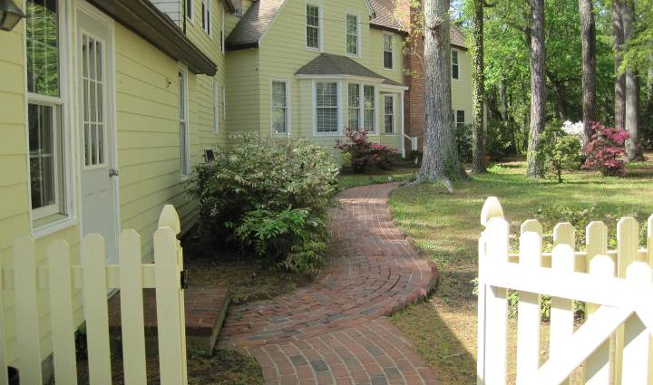Respite and renewal at Rehoboth Beach. The return of longer days, shorter nights. Time to come out of hibernation and write in the company of like-minded creatives. (Photo: JML Glenn)

Program Overview
- Pre-workshop conference call: For newbies and veterans (optional); details forthcoming.
- Friday, April 3: Welcoming Reception/Workshop Preview/Group Dinner (Begins 4:30 p.m.).
- Saturday, April 4: Morning and afternoon workshops. Lunch and dinner on your own. Optional consultations and evening gathering. (Program begins 9:30 a.m.)
- Sunday, April 5: Consultations, workshop, closing activities (ends 12 – 1 p.m.).

The Workshop
Nestled among the pines, just two blocks from the Atlantic Ocean and backing to Lake Gerar, Memorial House is gently sheltered from the hustle and bustle of the busy resort town of Rehoboth Beach.
Our schedule at this new venue is still focused but relaxed, with a balance of structured and unstructured time. Activities include individual writing, reflection, and response. The format can vary…we work together and alone, in whole groups or with partners. You are invited, but never required, to share your writing.
What will you take away? Seeds for future writing projects, a renewed commitment to regular writing practice in daily life, and reconnecting with the community of writers.

About Memorial House
Memorial House is the former summer house of the DuPont family. The house was gifted to the Episcopal Diocese of Rehoboth and is now used as a retreat center. Parking is available in the driveway and on the adjoining neighborhood streets.

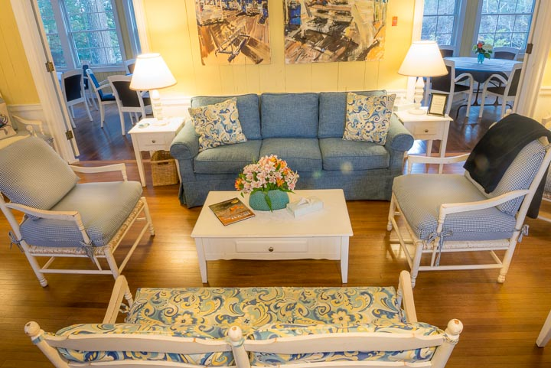Rooms are charming: simple, clean, small but comfortable, and all have private showers. Please note that the number of single rooms is limited. Memorial House has implemented a 15-person minimum so some rooms will need to be shared. (See “Registration and Housing” section for details.)

Our workshop is designed to accommodate approximately 15 participants. We’ll usually meet in the Chapel on the East Wing of the first floor. Some gatherings will be held in the living room.

Meals are included in your registration fee. We dine on-site, and vegetarian preferences can be accommodated—please let us know ahead of time so we can get word to the chef.

Coffee and tea are available in the dining room. If you travel with medications that need refrigeration, you can store them in the guest refrigerator.

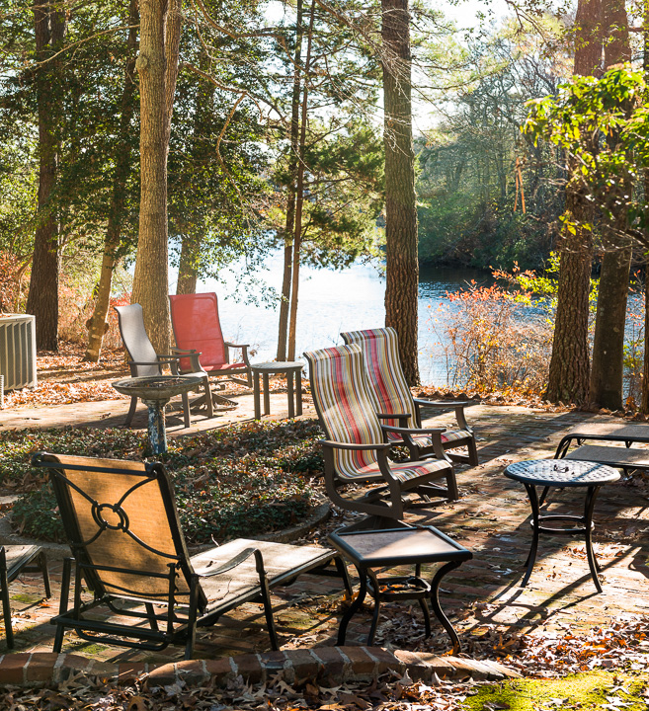Cell phone reception is not a problem. (Feel free to “unplug!”)

WiFi is available: Memorial House has free wireless internet (the signal is strongest the closer you are to the center of the House). The code and password are posted in the lounging area that adjoins the living room and back dining area.

You’ll have free time to write, to enjoy the deck or firepit (weather permitting), or to stroll the Boardwalk and shop. Memorial House is about a 10- to 15-minute walk from town (but only two blocks from the ocean, on the northern end of the Boardwalk).

Emergency care is available by dialing 911.

More information is available at http://www.memorialhouse.org/

Join us!
A registration and housing form follows on the next page. Early bird discounts are available through Feb. 28.

After I receive your registration, I’ll email you to let you know if you have a space in the workshop. As March nears, I’ll contact you about scheduling a pre-retreat conference call.

About a week in advance of the retreat, I’ll email you a confirmation letter and a full list of everything you need to know, including any pre-retreat prep and, of course, directions.
Registration and Housing
About you
Name ___________________________________ Best phone number_________________________
Best email _____________________Emergency contact+phone______________________________
Dietary restrictions _____None _____Vegetarian _______Other(pls. list)_______________________
Food allergies? Y N If yes, please list __________________________________________________
Mobility concerns? Y N If yes, please list ________________________________________________

Your writing
What are you working on and how’s it going?_____________________________________________
_________________________________________________________________________________
Is there any aspect of writing you particularly want to explore? ______________________________

If you’re new: When can you join us for a brief pre-retreat conference call?
____ Mon., Mar. 16, 7 pm ET ____ Thurs., Mar. 19, 7 pm ET _____ Mon., Mar. 23, 7 pm ET

Fees this year are based on Memorial House’s new policy: a15-person minimum. This is why the pricing below includes a single room supplement. Fees are still all-inclusive: workshop, lodging, 6 meals, evening reception, and snacks during workshop time.

Questions? Call 703.721.2088 |  | On or before Feb. 28* | After  Feb. 28
- Single room, 1 person** |  | $574 | $680
- Double (2 people) (please fill out roommate section below)*** |  | $968 | $1354
- Discount for WTWPWN alumnus (meaning you’ve attended any of my writing retreats previously) |  | Subtract $25 per person | Subtract $10 per person
- Total due (add A+ C or B + C )
*Bonus with early payment in full: 1 free post-workshop manuscript edit or consult (up to 2500 words) by Feb. 1, 2021.
**Pricing reflects increased Memorial House adjusted rates for 2020 and single supplement.
***Pricing reflects charge for 2 people sharing the same room. Please fill out roommate section below.

IMPORTANT: LODGING FLEXIBILITY
Memorial House has 11 rooms and a minimum participation rate of 15 people. Ideally we will house all participants onsite and be able to accommodate room-sharing preferences. I’m hoping for at least seven single and three shared rooms (i.e., 2 people per room, so 6 people willing to buddy-up). However, I ask your flexibility if we need to adjust accommodations one way or another. If you have special concerns, please let me know.

Rooms will be assigned on a first-come, first-served basis, and we need to fill the House first. Participants registering AFTER rooms have been filled will be offered a commuter meal rate at Memorial House and will be able to arrange their own accommodations at The Breakers Hotel or a similar property. Fees will be adjusted accordingly:

“Retreat + meals onsite/accommodations offsite” cost is estimated (based on previous years) at about $640/single, less applicable discount. “Retreat, no meals, accommodations offsite” cost is estimated at $470/single, less applicable discount.

About your roommate (if applicable)
Name ___________________________________ Best phone number_________________________
Best email _____________________Emergency contact+phone______________________________
Dietary restrictions _____None _____Vegetarian _______Other(pls. list)_______________________
Food allergies? Y N If yes, please list __________________________________________________
Mobility concerns? Y N If yes, please list ________________________________________________

Your roommate’s writing
What are you working on and how’s it going?_____________________________________________
_________________________________________________________________________________
Is there any aspect of writing you particularly want to explore? ______________________________

If your roommate is new: When can you join us for a brief pre-retreat conference call?
____ Mon., Mar. 16, 7 pm ET ____ Thurs., Mar. 19, 7 pm ET _____ Mon., Mar. 23, 7 pm ET

Payment
Payment Method ____ Check ____ Cashier's Check ____ Money Order
Make checks payable to Joanne Lozar Glenn

Please initial one choice of payment plan:
_____I am enclosing a nonrefundable $100 deposit to hold my space ($200 if this registration is for two people) and will pay the balance by (check one) __ Feb. 28 for early bird discount; ____Mar. 12 for regular registration.

_____I am paying in full. BONUS with early payment in full: Free post-conference edit of one composition up to 2500 words; offer good until February 1, 2021.

Note: If you prefer, PayPal is available but requires a processing fee. Email (info@wtwpwn.com) if you’d like to use PayPal.

Fee: $ ______________ (Line D from previous page)

Total Enclosed $ ______________

Mail payment and pages 3 and 4 of this document (be sure to keep a copy for your records) to:
Joanne Lozar Glenn
c/o Write Time, Write Place, Write Now
6600 Potomac Ave., B1
Alexandria, VA 22307

Waiver of Liability
I understand that my participation in this writing workshop is voluntary and that I knowingly assume any and all associated risks. I also agree to indemnify and hold Joanne Lozar Glenn and the host and hosting facility harmless from any and all claims, actions, expenses, damages, and liabilities, including attorneys’ fees, and not to sue for any claim for damages arising or growing out of my voluntary participation in this writing seminar and to reimburse them for any such expenses incurred.
Signature______________________________________________________Date_____________
Roommate signature, if applicable___________________________________Date_____________

Cancellation Policy
Workshop fees are nonrefundable unless we can fill your space. If you find it necessary to cancel after you have already paid in full and we can fill your space, you will receive a refund (less the nonrefundable deposit) after the writing retreat is over. If we do not have enough participants to hold this workshop, you will be notified and refunds, less a $75 dollar processing fee that you can apply to a future writing retreat, will be made within two weeks of notification.

Thank You!

